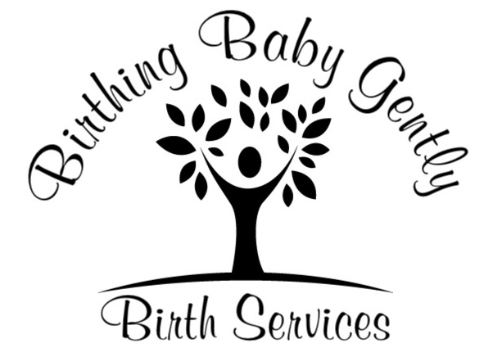

Placenta Encapsulation Contract

Placenta encapsulation is the process of preparing the mother’s placenta for ingestion by dehydrating it, making it into a powder and placing it into capsules. Placenta encapsulation has been practiced in Traditional Chinese Medicine and is believed to help new mothers with postpartum recovery.

Disclaimer:
Beneﬁts of placenta encapsulation are supported by ongoing research but have not been studied by the Food and Drug Administration. Your placenta capsules are a natural, nutritional supplement and cannot be guaranteed to produce specific results.

Client Responsibility:
It is your responsibility to notify me as soon after the birth as possible to make arrangements for pickup. Failure to do so may result in delayed placenta preparation and may lead to decreased potency of nutrients, hormones and other beneﬁcial attributes of your placenta. Delayed refrigeration of the placenta could lead to spoiling, which would render the placenta unsuitable for encapsulation. When possible place ice around the container for optimal freshness.

Finances:
My placenta encapsulation fee is $250. A deposit of $100. is due upon signing of the contract. Payment is due in full before capsules are given to client. Deposit is accepted in cash , check, Pay Pal or cc ( through square reader) . In the event that I am unable to provide services the client will be refunded deposit and no future payment is due. If the client does not notify me after the birth or is unable to provide the placenta for encapsulation, I will keep the deposit.

Agreements:
- It is the clients’ responsibility to discuss release of placenta from the facility where giving birth and to ensure proper storage in a refrigerator or cooler. (client’s initials - CI)
- It is the clients’ responsibility to inform me of any known blood-borne illness or Condition (HIV, Hepatitis, etc.) that could place me or others at risk. (CI)
- If you are willing to give permission for your placenta to be photographed for purposes of education, marketing and advertising, please initial here (CI)
- I would like prints made of my placenta (CI)
- I would like a tincture (C.I)
- I would like a keepsake cord (CI)
Mothers name : age:
EDD: Birth location:
Spouse/partner name: age:
Address:
Email:
Spouse / partner Email:
Home phone: Mothers cell:
Spouse/partner Cell: work :
Food allergies or intolerances?
Are you allergic to latex? Yes No
Have you had any of the following during this pregnancy: (circle all that apply) Herpes Group B Strep Hep B Hep C STDʼs (Chlamydia, HIV, HPV, etc.) Other Infections/ Disease please specify.
- I would like TMC method ____ (CI) or I would like raw method ____(CI)

